Standing Male Worshiper Ca. 2900-2600 B.C

Name
Institution affiliation
Course name
Instructor
Date

Standing Male Worshiper Ca. 2900-2600 B.C
The standing male worshiper status represents a male worshiper who existed in Mesopotamia around 2700BCE. Families and people who lived in Mesopotamia and modern Tell Asmar during the Early Dynastic Period made male worshippers. The status creators purposed to place them in the temples. They were to serve as constant worshippers of the Mesopotamian gods. The people believed that each status had a special place for their owners at all times. The people or families involved in creating the status and placing them in the temples permanently placed themselves in the presence of their gods. They were to worship the gods without ceasing constantly. They are believed to pray perpetually for the people whom they represent. According to historians, the status is historically unique since it is believed to be among the few exclusive examples of the intellectual style used to design status during the Early Dynastic temple sculpture. The male worshiper status is now located in the Metropolitan Museum of Art (MET). The standing Male worshiper is made from gypsum alabaster. It has clasped hands and a wide-eyed gaze. People living in Mesopotamia believed that gods were supposed to be in physical form. Their physical form, made of materials, gave them a real experience of what the people were going through and could help them manage their situations properly. Also, there was similar status designed and inscribed with great and prominent families and rulers of the time.
The statue was measured to have heights ranging from 21cm to 72 cm. It depicted a man with wide eyes, clasped hands in front of him, and long facial hair. The statues had broad and thick shoulders, with circular arms on the bare chest. The designer of the male worshiper statues used shells, limestone, and gypsum. According to Frankfort, the hoard discovered underneath the temples had unnaturally large eyes resembling those of an eagle. The eyes were extraordinary, symbolizing that they are forever open in prayers and always worshiping their gods. Another exciting feature about the statues is that they have a nose and mouth that are geometrically shaped. The nose is perfectly shaped triangularly, with a mouth containing two horizontal rectangles. The long hair and beard made it impossible to see the neck of the statues and had a round face. Looking at the upper arms, they are thicker than the lower arms. The statues had small hands with thin fingers visible in the front below the beard and clasped in the form of praying. However, the rest of the body is below the arms shaped in the form of a cylinder. It is evidence of the dress or custom of the people in the region. Checking keenly at the lower section of the body, the first half is smooth, but the rest of the section to the bottom has vertical lines that meet at a sharp point.
In some instances, metal would be used to make the statues where necessary. According to early archeologists, Mesopotamians could use metal to carve the stones and shaping the beards, eyes, and statues' faces. The use of metals shows that Mesopotamians civilization standards had highly improved and advanced. Nevertheless, the Mesopotamians could not major in using metal to make the statues since there were no ores in their land. They used to trade oil, textile among other commodities, with their neighbors to acquire the metal. Mesopotamia had a great advantage from an open geographical landscape, which helped open its boundaries easing trade, transport, and communication with neighboring cities. Mesopotamia led to the introduction of trade routes that later served as a platform for development in any world.
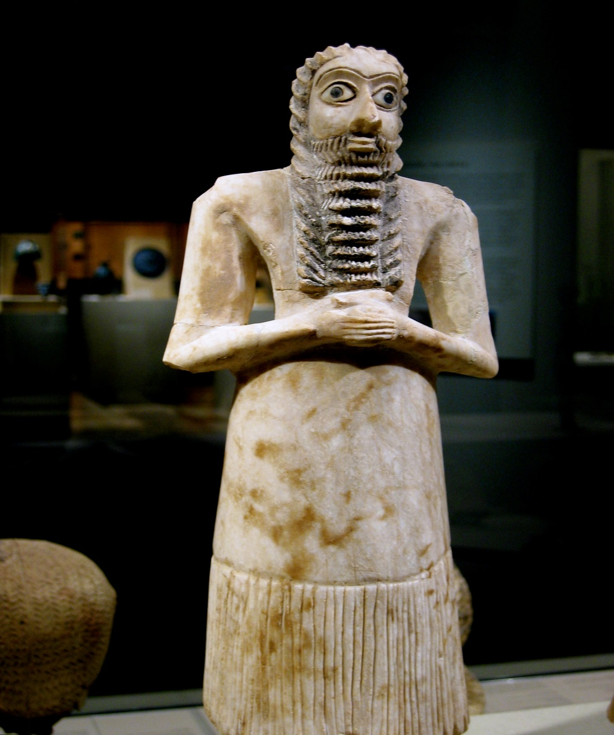
https://www.metmuseum.org/art/collection/search/323735

The first standing male worshipers were discovered in 1933 at Eshnunna, which is the modern Asmar. This is located in Diyala Governorate in Iraq. The discovery of the status in that site and other areas around the Mesopotamian area remains a unique style of Early Dynastic temple sculpture. However, some ancient historians and archeologists suggest that there were antique dealers in Baghdad who possessed large amounts of artifacts in the late 1920s. Between 1930 and 1937, Frankfort was an archeologist who worked with a team that handled an extrusive horizontal and vertical research program on four mounds in Iraq. These mounds included the Khafajah, Ishchali, Tell Agrab, and Tell Asmar, the ancient Eshnunna. Here, the team uncovered various temples, homes, administrative houses, and palaces that were believed to have existed between 3100 to 17500 B.C.
During their uncovering process, they managed to recover hundreds of artifacts from stratified ruins in a variety of these ancient civil structures. The artifacts helped to improve immensely the understanding and knowledge of the Early Dynastic periodization. Among the renowned recovered objects are the twelve statues best known as the Tell Asmar Hoard. The Tell Asmar was found beneath a temple's floor and was believed to have been dedicated to the god Abu. According to Frankfort and his team, the statues were well-preserved in a cavity located beside the temple's altar in the sanctuary. The careful placement made them believe that the statues were buried intentionally. However, the reasons behind hiding the statues by burying them remain unclear to date. Frankfort suggested that priests might have periodically buried the old and damaged statues to create more room for replacements with new ones in the temple.
When the Mesopotamian male worshiper statues were being introduced in the main Mesopotamia cities, the economic situation of the region was growing and blossoming. The region was experiencing great growth through trade and irrigation as their main source of wealth. Considering the region's economic status, the Mesopotamians found reasons to develop centers for religious practices alongside developing cities. The development of the first city-states led to a distinctive hierarchy of power. At the time, Urak was under the reign of the Sumerians. It meant that there was no confirmation of leadership positions as the ruling families already determined the ruler. It went for a long time until Akkadians took over Mesopotamia, developing an elite member of the society. The leadership brought about the purpose of having statues to show respect for the individuals who have ruled over Mesopotamia. Moreover, there were designing statues that people were required to pay tribute to on a daily basis. They acted as their gods, who should be adored and respected. For that reason, the Mesopotamians developed a worshipping culture that was believed to ensure that their gods are ever happy. With that, they were guaranteed to receive utmost protection from their gods. No Mesopotamians special enough not to worship the gods as they have been taught the importance of keeping the gods happy. They were required to pass these important lessons to their generations.
The majority of the standing male worshipers in existence today are known to have been recovered by various museums. Among the famous museums which have facilitated the recovery of the Early Dynastic Period statues is the Metropolitan Museum. Reports indicate that the museum funded the recovery of the statues in the periods between 1957-1958 and 1960-1961. The museum enabled the recovery of thousands of Early Dynastic Mesopotamian statues. The museum's initiative to sponsor the discovery and recovery of the statues allowed it to receive awards for some of such statues. According to archeologists, the male worshipper statues was a representation of the introduction of a variety of social function that is still taking place in the world today. The designers used stones to carve different figures that played a great role as tributes. The figures were not only used for religious purposes but represented people of importance in society. It was evident that technology was responsible for the improvement of skills and techniques to inventing things. Also, the presence of the statues showed that people had much respect for higher positions of authority and power. The design of the statues helped to represent individuals' existence without depicting gods. It is important that society designed sculptures of prominent individuals in society, those who held high positions and power like the kings and gods, showing their respect for them.
Today, the male worshiper statues are associated with religious practices in different cultures. Many cultures have similar statues which aren't built in the same way as the make worshiper statues. However, they still have their own essence in the communities. The people have the responsibility to pay tribute to the statues as they are their gods. They are required to make sure their gods are happy and give them personal belongings as a sign of respect and love. Some include rituals, such as offering livestock sacrifices, while others donate part of their farm produce to the temples where their gods live to make them happy. These are among the practices that are still practiced today by many religious persons bringing their possessions to value their religious places of their gods. People are using the statues as their gods, showing them much respect, and bringing possessions to them to receive protection. Cultures across the world believe that gods help them solve their issues amicably.

Work cited
Basedau, Matthias, and Johanna Schaefer-Kehnert. "Religious discrimination and religious armed conflict in sub-Saharan Africa: an obvious relationship?." Religion, State & Society 47, no. 1 (2019): 30-47.
Horejs, Barbara, Christoph Schwall, Vera Müller, Marta Luciani, Markus Ritter, Mattia Giudetti, Roderick B. Salisbury, Felix Höflmayer, and Teresa Bürge. "of the 10th International Congress on the Archaeology of the Ancient Near East."
Meerchyad, Lina. "Ancient Mesopotamian Seals: in the Collection of the Detroit Institute of Arts." Bulletin of the Detroit Institute of Arts 90, no. 14 (2016): 58-71.
Padhi, Soubhagya Ranjan, and Manash Pratim Goswami. "Tribal Folklore to Aesthetic and Religious Painting: Transition of Oral Narratives to Visual Art." Journal of Religion and Health (2020): 1-12.

Meerchyad, Lina. "Ancient Mesopotamian Seals: in the Collection of the Detroit Institute of Arts." Bulletin of the Detroit Institute of Arts 90, no. 14 (2016): 58-71.
Padhi, Soubhagya Ranjan, and Manash Pratim Goswami. "Tribal Folklore to Aesthetic and Religious Painting: Transition of Oral Narratives to Visual Art." Journal of Religion and Health (2020): 1-12.
Meerchyad, Lina. "Ancient Mesopotamian Seals: in the Collection of the Detroit Institute of Arts." Bulletin of the Detroit Institute of Arts 90, no. 14 (2016): 58-71.
Meerchyad, Lina. "Ancient Mesopotamian Seals: in the Collection of the Detroit Institute of Arts." Bulletin of the Detroit Institute of Arts 90, no. 14 (2016): 58-71.
Meerchyad, Lina. "Ancient Mesopotamian Seals: in the Collection of the Detroit Institute of Arts." Bulletin of the Detroit Institute of Arts 90, no. 14 (2016): 58-71.
Meerchyad, Lina. "Ancient Mesopotamian Seals: in the Collection of the Detroit Institute of Arts." Bulletin of the Detroit Institute of Arts 90, no. 14 (2016): 58-71.
Padhi, Soubhagya Ranjan, and Manash Pratim Goswami. "Tribal Folklore to Aesthetic and Religious Painting: Transition of Oral Narratives to Visual Art." Journal of Religion and Health (2020): 1-12.
Basedau, Matthias, and Johanna Schaefer-Kehnert. "Religious discrimination and religious armed conflict in sub-Saharan Africa: an obvious relationship?." Religion, State & Society 47, no. 1 (2019): 30-47.
Horejs, Barbara, Christoph Schwall, Vera Müller, Marta Luciani, Markus Ritter, Mattia Giudetti, Roderick B. Salisbury, Felix Höflmayer, and Teresa Bürge. "of the 10th International Congress on the Archaeology of the Ancient Near East."
Horejs, Barbara, Christoph Schwall, Vera Müller, Marta Luciani, Markus Ritter, Mattia Giudetti, Roderick B. Salisbury, Felix Höflmayer, and Teresa Bürge. "of the 10th International Congress on the Archaeology of the Ancient Near East."

